Software development methodologies play a vital part of developing the software. There are many methodologies which are used by the professional software development companies nowadays. There are certain advantages and disadvantages associated with each of them. The basic purpose of these methodologies is to provide smooth software development according to the project requirements.

Software development methodology is a framework that is used to structure, plan, and control the process of developing an information system. This kind of development methodologies are only concerned with the software development process, so it does not involve any technical aspect of, but only concern with proper planning for the software development.

Below are the 12 mainly used software development methodologies with their advantages and disadvantages:

|  |  |  |
| --- | --- | --- |
| Waterfall Model | Prototype Model | Agile software development |
| Rapid Application Development | Dynamic Systems Development Model | Spiral Model |
| Extreme Programming | Feature Driven Development | Joint Application Development |
| Lean Development | Rational Unified Process | Scrum Development |

1. Waterfall Model

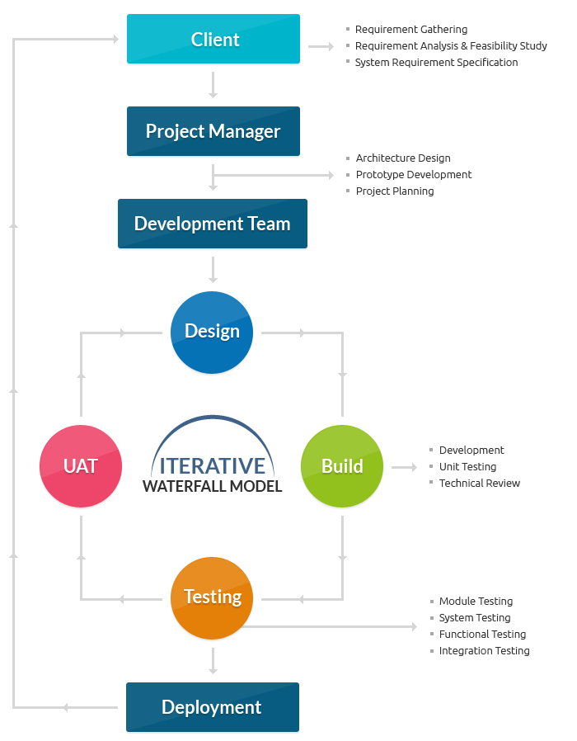  
The waterfall model is one of the most traditional and commonly used software development methodologies for software development. This life cycle model is often considered as the classic style of the software development. This model clarifies the software development process in a linear sequential flow that means that any phase in the development process begins only if the earlier phase is completed. This development approach does not define the process to go back to the previous phase to handle changes in requirements.

**Advantages of Waterfall Model:**

* Waterfall model is very simple and easy to understand and use a method that is why it is really beneficial for the beginner or novice developer
* It is easy to manage, because of the rigidity of the model. Moreover, each phase has specific deliverables and individual review process
* In this model phases are processed and completed are at once in a time thus it saves a significant amount of time
* This type of development model works more effectively in the smaller projects where requirements are very well understood
* The testing is easier as it can be done by reference to the scenarios defined in the earlier functional specification

**Disadvantages of Waterfall Model:**

* This model can only be used when very precise up-front requirements are available
* This model is not applicable for maintenance type of projects
* The main drawback of this method is that once an application is in the testing stage, it is not possible to go back and edit something
* There is no possibility to produce any working software until it reaches the last stage of the cycle
* In this model, there is no option to know the end result of the entire project
* This model is good for a small project but not ideally suitable for long and ongoing projects
* Not ideal for the projects where requirements are very moderates, and there is great scope for modification

2. Prototype Methodology

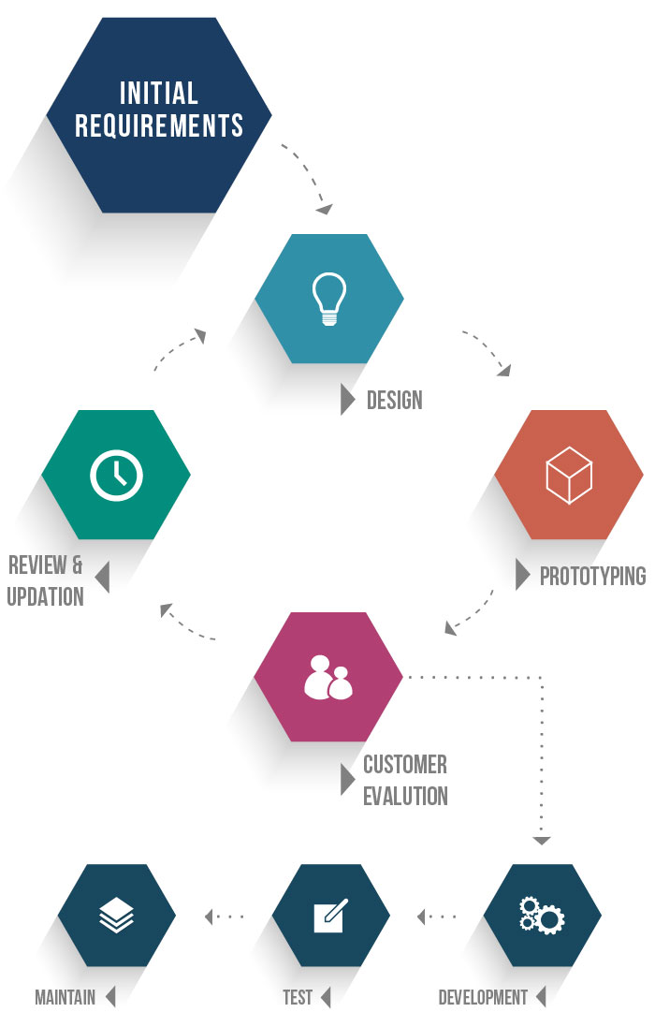  
The prototype methodology is the software development process which allows developers to create only the prototype of the solution to demonstrate its functionality to the clients and make necessary modifications before developing the actual application. The best feature of this software development methodologies is that it solves many issues which often occur in a traditional waterfall model.

**Advantages of Prototype Model:**

* When a prototype is shown to the clients, they get a clear understanding and complete 'feel' of the functionality of the software
* This method significantly reduces the risk of failure, as potential risks can be identified in early stage and moderation steps can be taken quickly
* The communication between software development team and the client makes very good and conducive environment during a project
* It helps in requirement gathering and requirement analysis when there is lack of requirement documents

**Disadvantages of Prototype Model:**

* Prototyping is usually done at the cost of the developer so, it is should be done using minimal resources otherwise organization’s development cost stretch too much
* Too much involvement of client is not always favored by the software developer
* Too many modifications may not good for the project, as it easily disturbs the workflow of the entire software development team

3. Agile Software Development Methodology

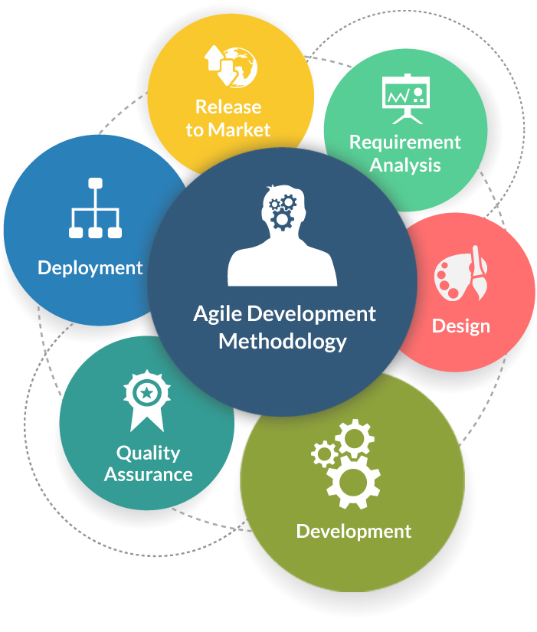  
Agile Software Development is an approach that is used to design a disciplined software management process which also allows some frequent alteration in the development project. This is a type of software development methodologies which is one conceptual framework for undertaking various software engineering projects. It is used to minimize risk by developing software in short time boxes which are called iterations that generally last for one week to one month.

**Advantages of Agile Development Methodology:**

* Agile methodology has an adaptive approach which is able to respond to the changing requirements of the clients
* Direct communication and constant feedback from customer representative leave no space for any guesswork in the system

**Disadvantages of Agile Development Methodology:**

* This methodology focuses on working software rather than documentation, hence it may result in a lack of documentation
* The software development project can get off track if the customer is not very clear about the final outcome of his project

4. Rapid Application Development (RAD)

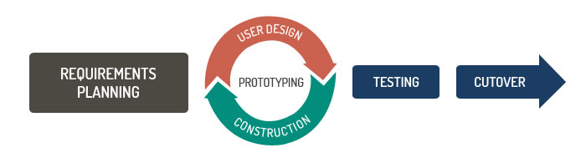  
Rapid Application Development (RAD) is an effective methodology to provide much quicker development and higher-quality results than those achieved with the other software development methodologies. It is designed in such a way that, it easily take the maximum advantages of the software development. The main objective of this methodology is to accelerate the entire software development process. The goal is easily achievable because it allows active user participation in the development process.

**Advantages of the RAD model:**

* Rapid Application development model helps to reduce the risk and required efforts on the part of the software developer
* This model also helps client’s to take quick reviews for the project
* This methodology encourages customer feedback which always provides improvement scope for any software development project

**Disadvantages RAD model:**

* This model depends on the strong team and individual performances for clearly identifying the exact requirement of the business
* It only works on systems that can be modularized can be built using this methodology
* This approach demands highly skilled developers and designer’s team which may not be possible for every organization
* This method is not applicable for the developer to use in small budget projects as a cost of modeling and automated code generation is very high

5. Dynamic Systems Development Model Methodology

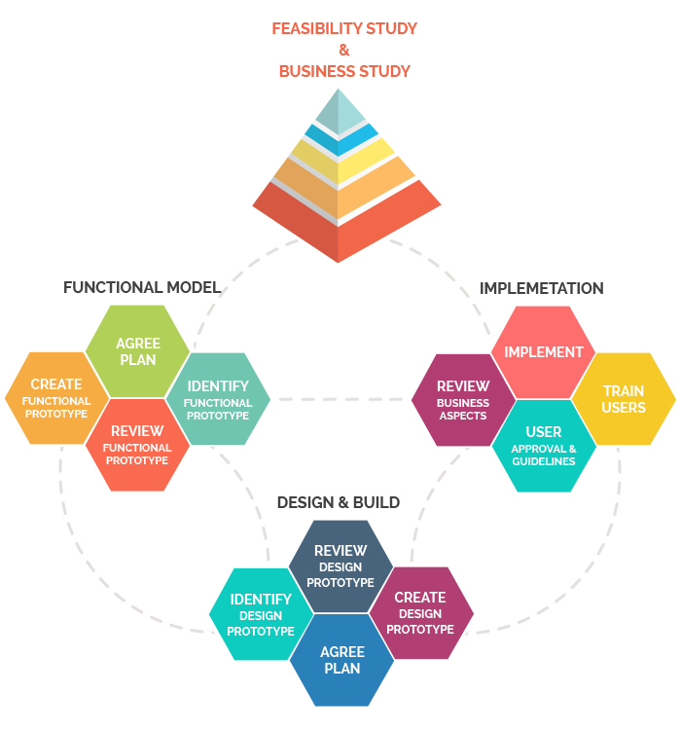

Dynamic Systems Development Model is a software development methodology originally based on the Rapid Application Development methodology. This is an iterative and incremental approach that emphasizes continuous user involvement. Its main aim is to deliver software systems on time and on the budget. This model simply works on the philosophy that nothing is developed perfectly in the first attempt and considers as an ever-changing process.

**Advantages of Dynamic Systems Development Model:**

* Users are highly involved in the development of the system so, they are more likely to get a grip on the software development project
* In this model, basic functionality is delivered quickly, with more functionality being delivered at frequent intervals
* This method provides an easy access by developers to end-users
* In this kind of development, approach projects are delivered on time and within a specific budget

**Disadvantages of Dynamic Systems Development Model:**

* The first thing is DSDM is costly to implement, as it requires users and developers both to be trained to employ it effectively. It may not be suitable for small organizations or one-time projects
* It is a relatively new model, therefore, it is not very common and easy to understand

6. Spiral Model

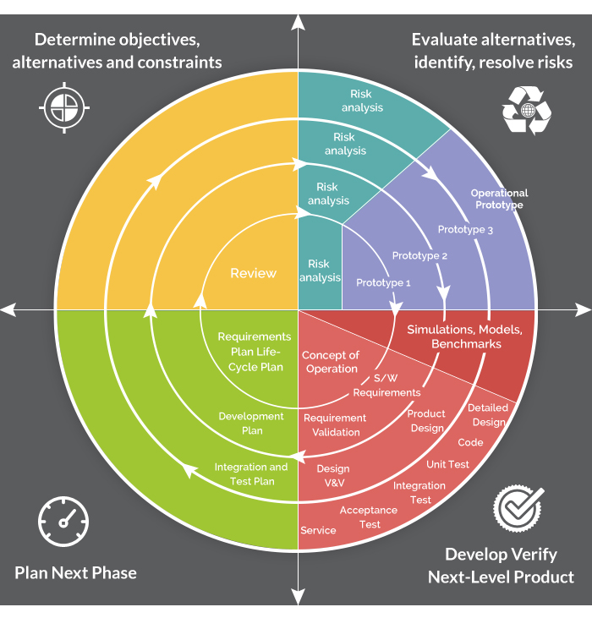  
The Spiral Model is a sophisticated model that focuses on early identification and reduction of project risks. In this software development methodology, developers start on a small scale then explores the risks involved in the project, makes a plan to handle the risks, and finally decides whether to take the next step of the project to do the next iteration of the spiral. The success of any Spiral Lifecycle Model depends on the reliable, attentive, and knowledgeable management of the project.

**Advantages of Spiral Model:**

* The high amount of risk analysis hence, avoidance of possible risk is certainly reduced
* This model is good for large size and critical projects
* In the spiral model, additional functionality can be added at a later date
* It is more suited for high-risk projects, where business needs may differ from time to time basis

**Disadvantages of Spiral Model:**

* It is certainly the costly model to use in terms of development
* The success of the entire project is dependent on the risk analysis phase thus, failure in this phase may damage entire project
* It is not appropriate for low-risk projects
* The big risk of this methodology is that it may continue indefinitely and never finish

7. Extreme Programming Methodology

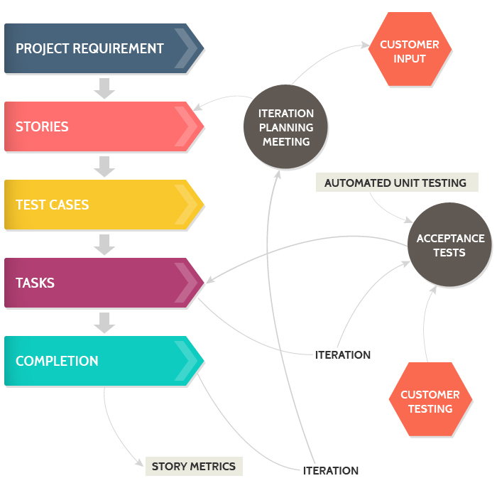  
Extreme Programming is an agile software engineering methodology. This methodology, which is shortly known as XP methodology is mainly used for creating software within a very unstable environment. It allows greater flexibility within the modeling process. The main goal of this XP model is to lower the cost of software requirements. It is quite common in the XP model that the cost of changing the requirements on later stage in the project can be very high.

**Advantages of Extreme Programming Methodology:**

* Extreme programming methodologies emphasis on customer involvement
* This model helps to establish rational plans and schedules and to get the developers personally committed to their schedules which are surely a big advantage in the XP model
* This model is consistent with most modern development methods so, developers are able to produce quality software

**Disadvantages of Extreme Programming Methodology:**

* This methodology is only as effective as the people involved, Agile does not solve this issue
* This kind of software development model requires meetings at frequent intervals at enormous expense to customers
* It requires too much development changes which are really very difficult to adopt every time for the software developer
* In this methodology, it tends to impossible to be known exact estimates of work effort needed to provide a quote, because at the starting of the project nobody aware about the entire scope and requirements of the project

8. Feature Driven Development

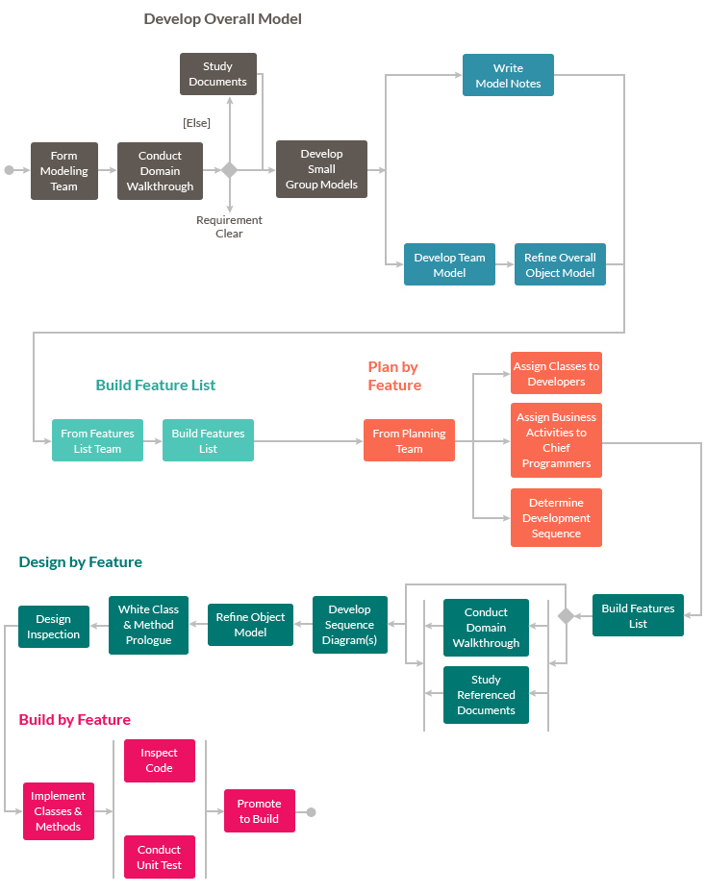  
Feature Driven Development is an iterative software development methodology intended for use by large teams working on a project using object-oriented technology. This type of model is good for organizations that are transitioning from a phase-based approach to an iterative approach, this methodology also known as an FDD methodology.

**Advantages of FDD Methodology:**

* FDD Helps to move larger size projects and obtain repeatable success
* The simple five processes help to bring work done in a short time and easiest manner
* This type of model is built on set standards for software development industry, so it helps easy development and industry recognized best practices

**Disadvantages of FDD Methodology:**

* Not an ideal methodology for smaller projects so, it is not good for an individual software developer
* High dependency on the main developer means the person should be fully equipped for an act as coordinator, lead designer, and mentor
* No written documentation provided to clients in this methodology so, they are not able to get a proof for their own software

9. Joint Application Development Methodology

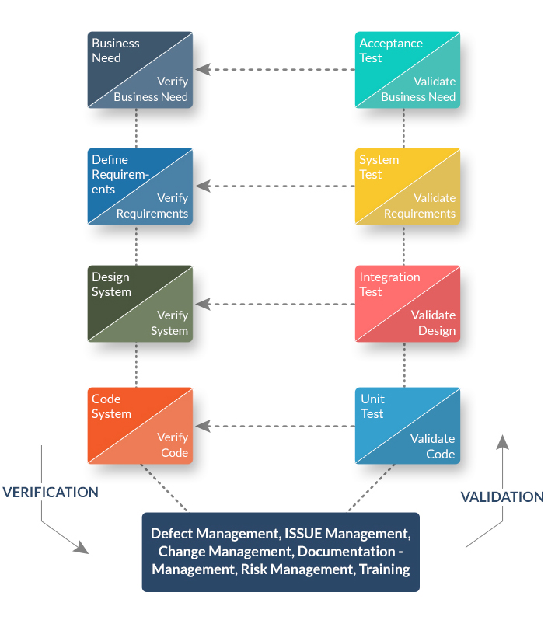

Joint Application Development (JAD) is a requirements-definition and user-interface development methodology in which end-users, clients, and developers attend intense off-site meetings to work out and finalize software system. This methodology aims to involve the client in the design and development of an application. This is easily accomplished through a series of collaborative workshops called JAD sessions. This model mainly focuses on the business problem rather than technical details therefore, it is mostly suitable for developing any kind of business systems.

**Advantages JAD Methodology:**

* This methodology allows for the simultaneous gathering and consolidating of large amounts of information
* This software development mode effectively produces large amounts of high-quality information in a short period of time
* In this methodology, differences are resolved immediately with the proper assistance of the organizer
* This model provides a forum to explore multiple points of view regarding a topic

**Disadvantages of JAD Methodology:**

* JAD methodology takes a large amount of time as it requires significant planning and scheduling effort on the part of the project development team
* It requires significant investor commitment in terms of the time and effort
* This approach requires trained and experienced personnel for effective implementation of the entire project

10. Lean Development Methodology

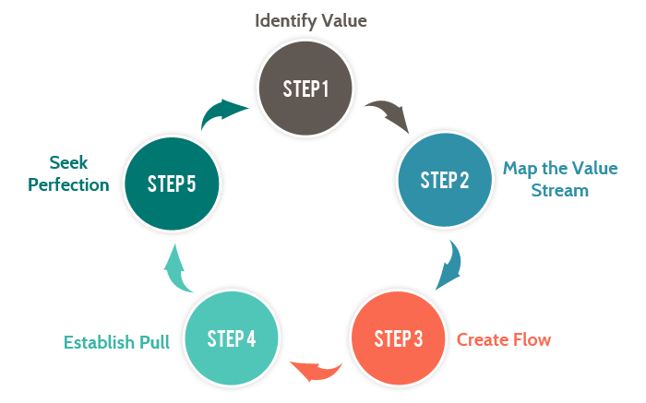  
Lean Development Methodology focuses on the creation of easily changeable software. This Software Development model is more strategically focused than any other type of agile methodology. The goal of this methodology is to develop software in one-third of the time, with very limited budget, and very less amount of required workflow.

**Advantages of Lean Development Methodology:**

* The early elimination of the overall efficiency of the development process certainly helps to speeds up the process of entire software development which surely reduces the cost of the project
* Delivering the product early is a definite advantage. It means that development team can deliver more functionality in a shorter period of time, hence enabling more projects to be delivered
* Empowerment of the development team helps in developing the decision-making ability of the team members which created more motivation among team members

**Disadvantages of Lean Development Methodology:**

* Success in the software development depends on how disciplined the team members are and how to advance their technical skills
* The role of a business analyst is vital to ensure the business requirements documentation is understood properly. If any organization doesn't have a person with the right business analyst then this method may not be useful for them
* In this development model, great flexibility is given to developer which is surely great, but too much of it will quickly lead to a development team who lost focus on its original objectives thus, it hearts the flow of entire project development work

11. Rational Unified Process Methodology

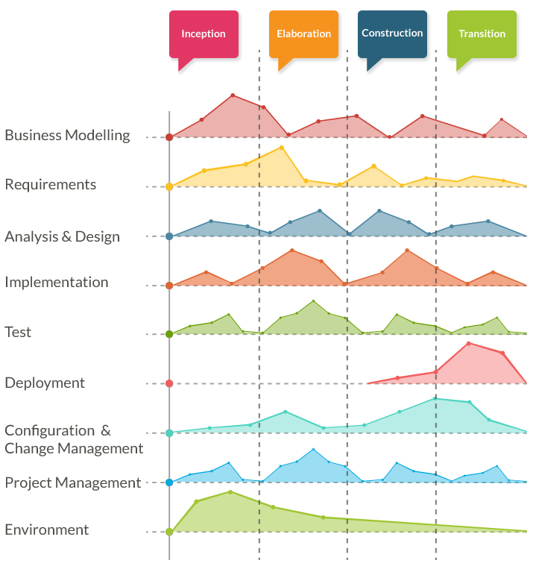

Rational Unified Process methodology is shortly known as an RUP is a one modern software development process. This methodology divides the development process into four distinct phases that each involves business modeling, analysis and design, implementation, testing, and deployment. This is an object-oriented and web-enabled program development methodology. This model also helps software developer for providing them guidelines, templates, and examples for all aspects and stages of software development.

**Advantages of RUP Software Development Methodology:**

* This methodology emphasizes on accurate documentation
* It is proactively able to resolve the project risks that are associated with the clients evolving requirements for careful changes and request management
* Very less need for integration as the process of integration goes on throughout the development process

**Disadvantages of RUP Software Development Methodology:**

* The software developer needs to be expert in their work to develop software under this methodology.
* The development process in this methodology is very complex and not exactly organized.
* Integration throughout the process of software development adds the confusion that causes more issues during the stages of testing.
* This process is too complex therefore it is very hard to understand.

12. Scrum Development Methodology

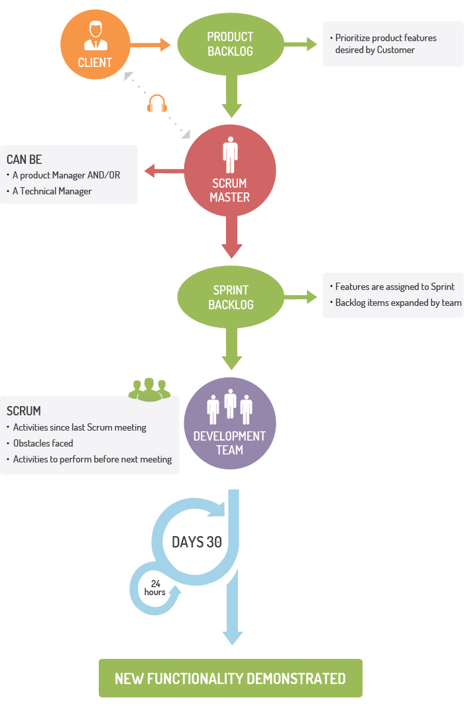

The Scrum Development Methodology can be applied to nearly any project. This process is suited for development projects that are rapidly changing or highly emergent requirements. The Scrum software development model begins with a brief planning, meeting and concludes with a final review. This development methodology is used for speedy development of software which includes a series of iterations to create required software. It is an ideal methodology because it easily brings on track even the slowest progressing projects.

**Advantages of Scrum Development:**

* In this methodology, decision-making is entirely in the hands of the teams
* This methodology enables project’s where the business requirements documentation is not considered very significant for the successful development
* It is a lightly controlled method which totally empathizes on frequent updating of the progress, therefore, project development steps is visible in this method
* A daily meeting easily helps the developer to make it possible to measure individual productivity. This leads to the improvement in the productivity of each of the team members

**Disadvantages of Scrum Development:**

* This kind of development model is suffered if the estimating project costs and time will not be accurate
* It is good for small, fast moving projects but not suitable for large size projects
* This methodology needs experienced team members only. If the team consists of people who are novices, the project cannot be completed within exact time frame

**Conclusion**

These above software development methodologies are very important which are mostly used for various software development projects. Moreover, all these methodologies work well in certain projects depending upon the nature of the project. It often happens that one methodology that is suited for a particular project may not be suited for another project. Moreover, none of these methodologies are foolproof as each has its own pros and cons. So, software developers must have information about all these methodologies before selecting any of these development methods for their software development projects. For better results, it is advisable to consult a professional software development company.